AIML SESSION 07 ASSIGNMENT SUBMISSION

Name of Student : Vaibhav Vijay Kate
Domain/Subject : AIML (Artificial Intelligence & Machine Learning)
College : Government Polytechnic College Washim
Branch : Information Technology
Session : 07

Q1
Q1. Creating Tuples)
Write a program to create tuples using different methods:
a) A tuple with 5 numbers using parentheses.
b) A mixed tuple containing integer, string, float, and boolean.
c) An empty tuple using two different ways.
d) A single-element tuple with the value 99.
Print all tuples and their types. Add comments explaining the rules for single-
element tuples.

Program Code:
# A tuple with 5 numbers using parentheses.
tup1 = (1,2,3,4,5)
# A mixed tuple containing integer, string, float, and boolean.
tup2 = (1,"Vaibhav",1.3,True)
# An empty tuple using two different ways.
# Method 1
tup3 = ()
# Method 2
tup4 = tuple()
# A single-element tuple with the value 99.
tup5 = (99,) # Single-element tuple (comma is required)
# Print all tuples and their types. Add comments explaining the rules for single element tuples.
print(type(tup1),tup1)
print(type(tup2),tup3)
print(type(tup4),tup4)
print(type(tup5),tup5)

Output Screenshot: 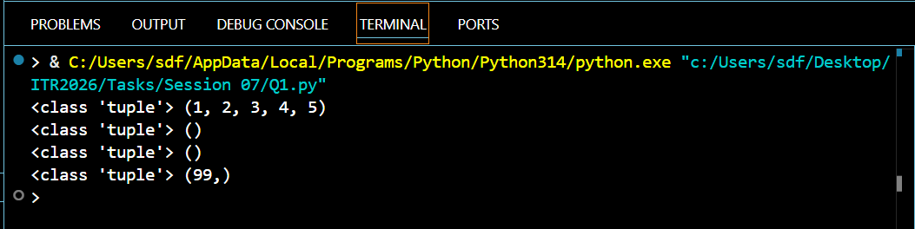

Q2
Q2. Tuple Packing)
Create a tuple without using parentheses (tuple packing) to store: your name, age,
and city.
Print the tuple and its type.
Then unpack the tuple into three separate variables and print them individually.

Program Code:
# Tuple Packing
tuple_Data = "vaibhav", 18, "Washim"
print(type(tuple_Data), tuple_Data)
# Tuple Unpacking
name, age, city = tuple_Data
print(name)
print(age)
print(city)

Output Screenshot: 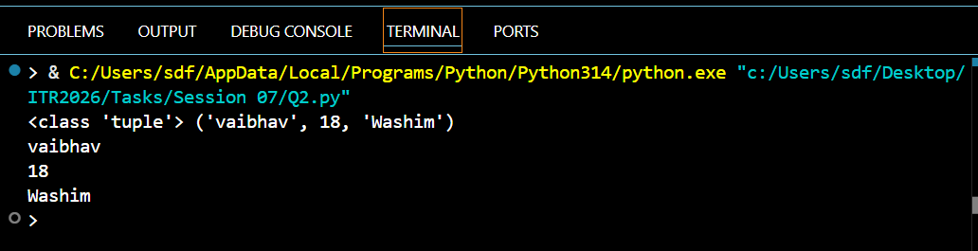

Q3
Q3. Indexing and Negative Indexing)
Create the tuple: colors = ('red', 'green', 'blue', 'yellow', 'purple', 'orange')
Print:
First element
Third element
Last element (using negative index)
Second last element (using negative index)
Take an index number as input from the user and print the element at that index.

Program Code:
# Creating a Tuple
colors = ('red', 'green', 'blue', 'yellow', 'purple', 'orange')
# First element
print(colors[0])
# Third element
print(colors[2])
# Last element (using negative index)
print(colors[-1])
# Second last element (using negative index)
print(colors[-2])
# Take an index number as input from the user and print the element at that index.
a = int(input("Enter the index value (0 to 5): "))
print(colors[a])

Output Screenshot: 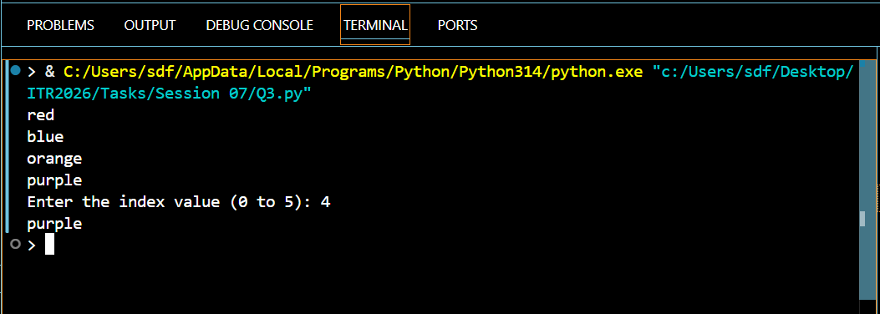

Q4
Q4. Slicing Tuples)
Given the tuple: numbers = 0, 1, 2, 3, 4, 5, 6, 7, 8, 9, 10
Using slicing, print:
a) Elements from index 2 to 7
b) First 5 elements
Session 07 (AIML) - Assignment Questions 1
c) Last 4 elements
d) Every second element
e) The entire tuple in reverse order
Add comments explaining the slicing syntax.

Program Code:
# Given the tuple: numbers = (0, 1, 2, 3, 4, 5, 6, 7, 8, 9, 10)
# Slicing Syntax :
# sequence [start : Stop : step]
numbers = (0, 1, 2, 3, 4, 5, 6, 7, 8, 9, 10)
# Elements from index 2 to 7
print(numbers[2:7])
# First 5 elements
print(numbers[0:5])
# Last 4 elements
print(numbers[7:11])
# Every second element
print(numbers[::2])
# The entire tuple in reverse order
print(numbers[::-1])

Output Screenshot: 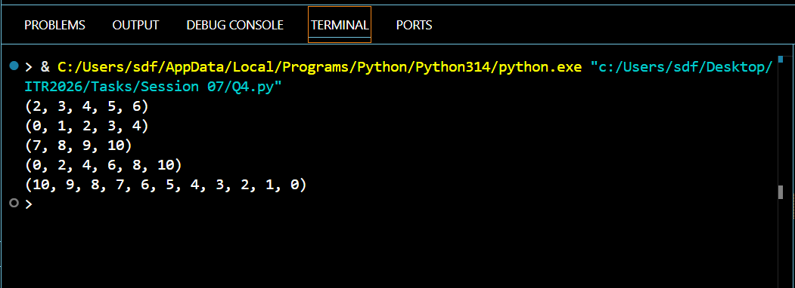

Q5
Q5. Nested Tuples)
Create a nested tuple to represent a 33 matrix:
matrix = 1, 2, 3, 4, 5, 6, 7, 8, 9
Print:
The first row
The element at second row, third column
The element at third row, first column

Program Code:
matrix = ((1, 2, 3),
(4, 5, 6),
(7, 8, 9))
# The first row
print(matrix[0])
# The element at second row, third column
print(matrix[1][2])
# The element at third row, first column
print(matrix[2][0])

Output Screenshot: 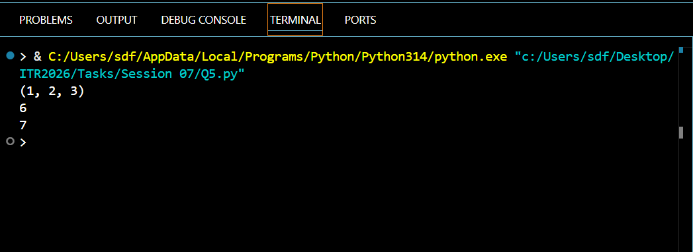

Q6
Q6. Iterating and Unpacking)
Create a tuple: student = ('Rahul', 20, 'Computer Science', 'A')
a) Iterate through the tuple using a for loop and print each item.
b) Unpack the tuple into four variables (name, age, branch, grade) and print them
with descriptive messages.

Program Code:
student = ('Rahul', 20, 'Computer Science', 'A')
# a) Iterating
print("Tuple Elements:")
for item in student:
print(item)
# b) Unpacking
name, age, branch, grade = student
print("\nStudent Details:")
print("Name:", name)
print("Age:", age)
print("Branch:", branch)
print("Grade:", grade)

Output Screenshot: 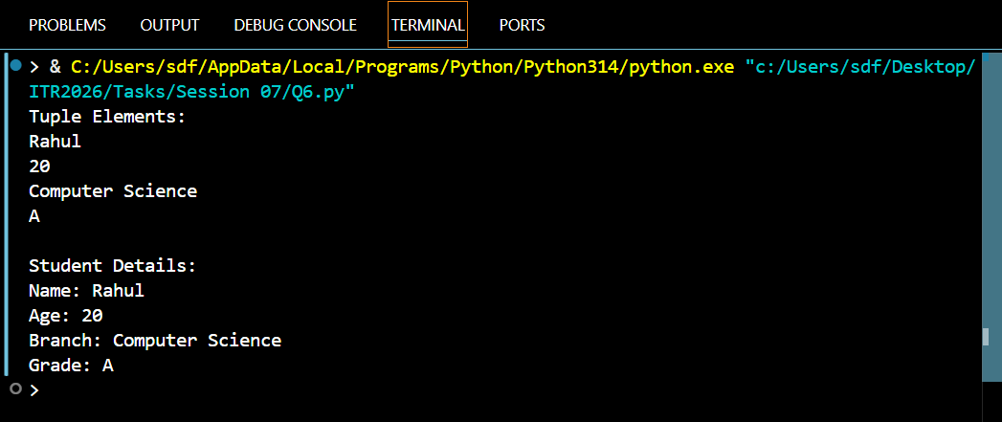

Q7
Q7. (count() Method)
Create the tuple: grades = ('A', 'B', 'A', 'C', 'A', 'B', 'D', 'A', 'B')
Count and print how many times 'A' appears.
Count and print how many times 'B' appears.
Take a grade as input from the user and print how many times it appears.

Program Code:
# Creating a Tuple
grades = ('A', 'B', 'A', 'C', 'A', 'B', 'D', 'A', 'B')
# Count and print how many times 'A' appears.
print("A Appears :",grades.count('A'),"Times")
# Count and print how many times 'B' appears.
print("B is Appears :",grades.count('B'),"Times")
# Take a grade as input from the user and print how many times it appears.
grade = input("Enter the grade to search: ")
count = grades.count(grade)
print(f"{grade} appears {count} time(s) in the tuple.")

Output Screenshot: 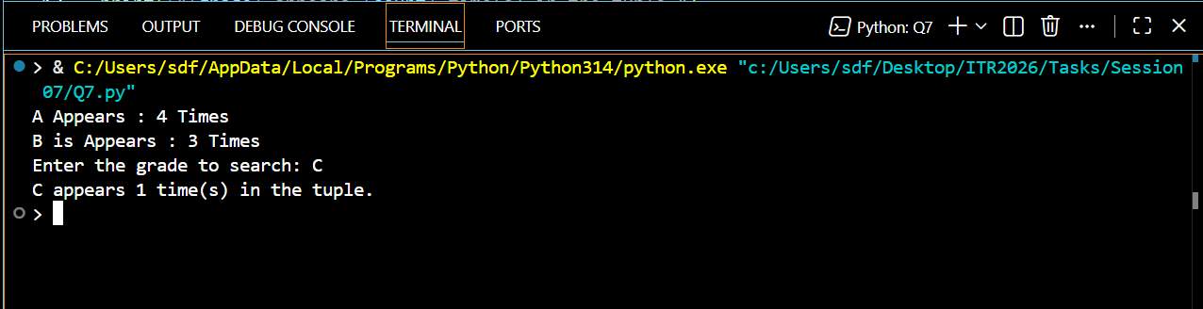

Q8
Q8. (index() Method)
Create the tuple: fruits = ('apple', 'banana', 'cherry', 'banana', 'mango', 'apple')
Find and print the first index of 'banana'.
Find and print the first index of 'banana' starting the search from index 2.
Use try-except to safely find the index of 'kiwi' and print "Not found" if it
doesn't exist.
Session 07 (AIML) - Assignment Questions 2

Program Code:
# Creating a Tuple
fruits = ('apple', 'banana', 'cherry', 'banana', 'mango', 'apple')
# Find and print the first index of 'banana'.
print(" Frist Index Of a banana :",fruits.index('banana'))
# Find and print the first index of 'banana' starting the search from index 2.
print(" Frist Index Of a banana :",fruits.index('banana',2))
# Use try-except to safely find the index of 'kiwi' and print "Not found" if it
fruits = ('apple', 'banana', 'mango', 'orange')
try:
index = fruits.index('kiwi')
print("Index ofkiwi:", index)
except ValueError:
print("Not found")

Output Screenshot: 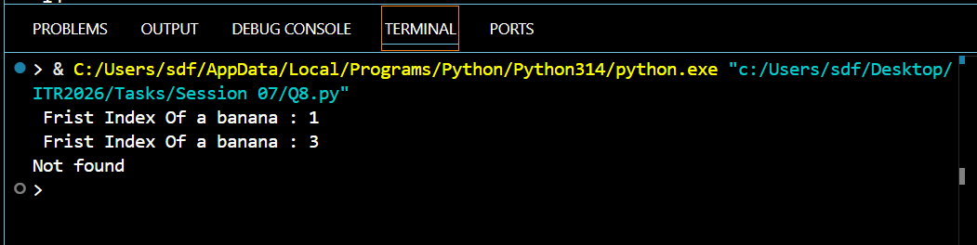

Q9
Q9. Immutability of Tuples)
Create a tuple: coordinates = 10, 20
Demonstrate that tuples are immutable by trying to:
Change the first element
Add a new element using append()
Explain what errors occur (in comments). Then show the correct way to modify
data by converting the tuple to a list, making changes, and converting back to a
tuple.

Program Code:
# (Immutability of Tuples)
# Create a tuple: coordinates = (10, 20)
# Demonstrate that tuples are immutable by trying to:
# Change the first element
# Add a new element using append()
# Explain what errors occur (in comments). Then show the correct way to modify
# data by converting the tuple to a list, making changes, and converting back to a
# tuple.
# Create a tuple
coordinates = (10, 20)
print("Original Tuple:", coordinates)
# Attempt 1: Change the first element
#coordinates[0] = 100
# Original Tuple: (10, 20)
# Traceback (most recent call last):
# File "c:\Users\sdf\Desktop\ITR2026\Tasks\Session 07\Q9.py", line 21, in <module>
# coordinates[0] = 100
# TypeError: 'tuple' object does not support item assignment
# Reason:
# Tuples are immutable, so their elements cannot be changed after creation.
# Attempt 2: Add a new element using append()
# coordinates.append(30)
# Error:
# AttributeError: 'tuple' object has no attribute 'append'
# Reason:
# Tuples do not have methods like append(), insert(), or remove().
# Correct Way: Convert tuple to list, modify, then convert back
# Convert tuple to list
coordinates_list = list(coordinates)
# Modify data
coordinates_list[0] = 100
coordinates_list.append(30)
# Convert back to tuple
coordinates = tuple(coordinates_list)
print("Modified Tuple:", coordinates)

Output Screenshot: 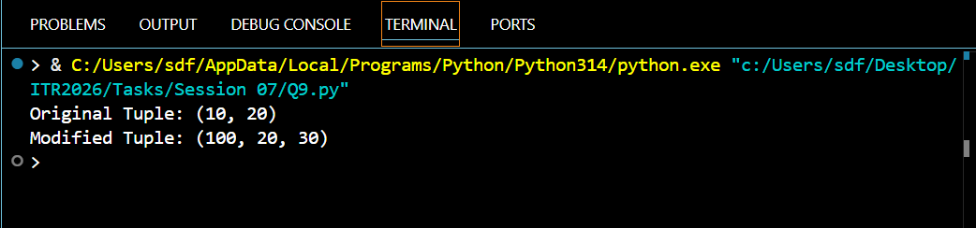

Q10
Q10. Mini Project - Combined Concepts)
Create a Student Record Program using tuples:
Take input for name, roll number, 3 subject marks.
Store all information in a tuple (use packing).
Print the complete record.
Unpack the tuple and print each value with proper labels.
Use count() to check how many times a particular mark appears (if any).
Create a nested tuple to store multiple student records (at least 2 students)
and access specific values.
Add meaningful comments and use proper formatting.
Session 07 (AIML) - Assignment Questions 3

Program Code:
# Q10. (Mini Project - Combined Concepts)
# Student Record Program using Tuples
# Take input from the user
name = input("Enter Student Name: ")
roll_no = int(input("Enter Roll Number: "))
mark1 = int(input("Enter Subject 1 Marks: "))
mark2 = int(input("Enter Subject 2 Marks: "))
mark3 = int(input("Enter Subject 3 Marks: "))
# Store all information in a tuple (Packing)
student = (name, roll_no, mark1, mark2, mark3)
# Print complete record
print("\n===== Student Record =====")
print(student)
# Unpack the tuple
name, roll_no, mark1, mark2, mark3 = student
# Print values with labels
print("\n===== Student Details =====")
print("Name :", name)
print("Roll No :", roll_no)
print("Subject 1 :", mark1)
print("Subject 2 :", mark2)
print("Subject 3 :", mark3)
# Count how many times a mark appears
search_mark = int(input("\nEnter a mark to count: "))
count_mark = student.count(search_mark)
print(f"{search_mark} appears {count_mark} time(s) in the record.")
# Create Nested Tuple (Multiple Students)
student1 = student
student2 = ("Rahul",102,85,90,88)
students = (student1, student2)
# Print Nested Tuple
print("\n===== All Student Records =====")
print(students)
# Access Specific Values
print("\n===== Accessing Specific Values =====")
# First student's name
print("First Student Name :", students[0][0])
# Second student's roll number
print("Second Student Roll No :", students[1][1])
# Second student's Subject 2 marks
print("Second Student Subject 2 Marks :", students[1][3])

Output Screenshot: 